**Practical 1**

**Aim: To perform Linux Commands**

1. Mkdir



1. Rmdir



1. Ls {-a , -l}

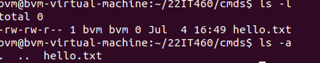

1. Cd



1. Echo



1. Touch



1. Cp



1. Mv



1. Rm



1. Cat

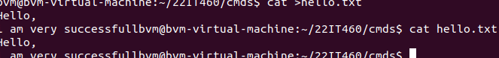

1. More



1. Less



1. Find



1. Grep



1. Which



1. Date



1. Chmod

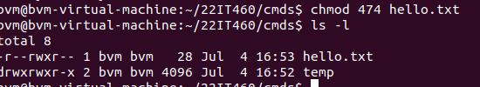

1. Locate



1. Du



1. Whoami



1. Apt update

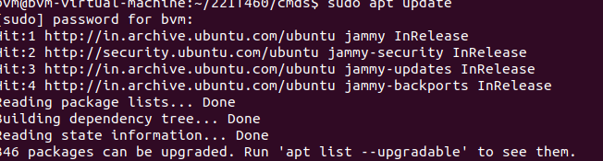

1. History

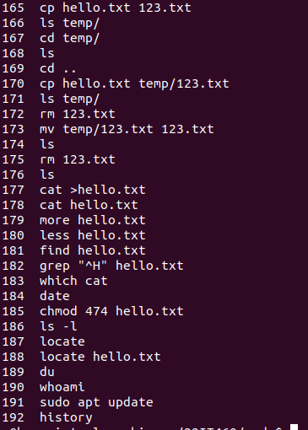

**Q1. Create a directory named “id_number” in your home directory.**



**Q2. Inside id_number, create two sub-directories: document and scripts.**

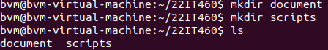

**Q3. Create an empty file called notes.txt inside document.**



**Q4. Copy notes.txt to the scripts directory.**



**Q5. Rename notes.txt inside scripts to backup.txt.**

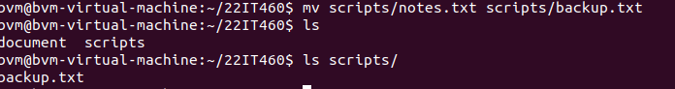

**Q6. Delete the backup.txt file from scripts.**



**Q7. Check the current permissions of notes.txt inside docs.**



**Q8. Change permissions of notes.txt so that only the owner can read and write it.**

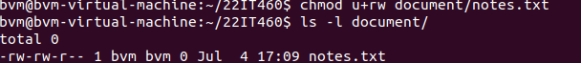

**Q9. Search for the file notes.txt starting from your home directory.**



**Q10. Add the text "Linux is powerful" to notes.txt.**



**Q11. Search for the word "powerful" inside notes.txt using grep.**

